**Rafting site – Planning Document**

1. Logo

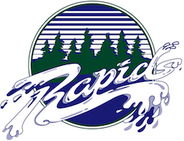

1. Color Scheme

* **Primary–color**: Periwinkle BEB8EB
* **Secondary–color**: Celestial Blue 5299D3
* **Accent1–color**: Midnight Green 0B5563
* **Accent 2- color**: White FEFFFF

1. Font

* **Heading-font: Bebas Neue, Regular 400**
* **Text-font: Open Sans, Light 300**

1. **Colours.co URL Link**

**https://coolors.co/palette/beb8eb-5299d3-0b5563-feffff**